PUJA Booking - Sri Vishnu Shiva Mandir – Canberra
82, Mawson drive, Mawson ACT 2607 Ph 02 6286 6404, email: info@vishnushivamandir.org.au
Sri Lakshmi Ganapathi Homam / Maha Sudharshana Homam
Happy New Year- Wishing you and your family a very happy 2022.
Saturday, 1 January 2022 @ 10.15
Reply email: mandirpoojas100@gmail.com
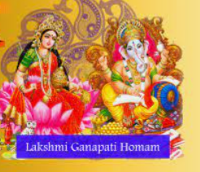 | 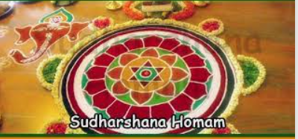

Names (Please add names of your family members) | Click here to enter text. | Click here to enter text. | Click here to enter text. | Click here to enter text.
Gothram | Click here to enter text. | Click here to enter text. | Click here to enter text. | Click here to enter text.
Nakshatram | Choose an item. | Choose an item. | Choose an item. | Choose an item.
Date | Saturday, 1 January 2022 @ 10.15
Payment | Payment to the Mandir’s netbank account.  Mandir Public Fund, Commonwealth Bank,  BSB: 062908, Account no: 1026 2406,  Account Ref: Your name and phone no

